BREAKFAST CHATTER
Weekly Bulletin of Rotary Club of Kathmandu Mid-Town
District 3290 Volume No. 15/42 for #784 May 13, 2005
www.rotarymidtown.org.np
MAY IS THE DISTRICT ASSEMBLY MONTH
☺ ☺ ☺ *** yours truly David S on 19 May *** ☺ ☺ ☺
*********MEETINGS & ACTIVITIES*******
DATE | ACTIVITY | SUBJECT
13 MAY | RAVINDRA SHAKYA | EMPOW’RING YOUNG PEOPLE-CIVIC EDUCATION
20 MAY | AMOD MANI DIXIT | DO THIS BEFORE TOMORROW’S EARTHQUAKE
23 MAY | BOARD MEETING | SAROJ SHRESTHA HOSTING
27 MAY | GOPAL KAKSHAPATI | CENTENNIAL FELLOWSHIP MEETING
03 JUN | KRISHNA BHATTARAI | HRDC RH PILOT PROJECT
10 JUN | DAVID WARD | TOPIC TO BE ANNOUNCED
16 JUN | BOARD MEETING | ARUN SHERCHAN HOSTING
17 JUN | CLUB ASSEMBLY | LAST BUT NOT LEAST
24 JUN | DAVID SOWERWINE | FOOTLIGHTS FOR THE HIMALAYAS
01 JUL | R M-T BOARD | INSTALLATION CEREMONY

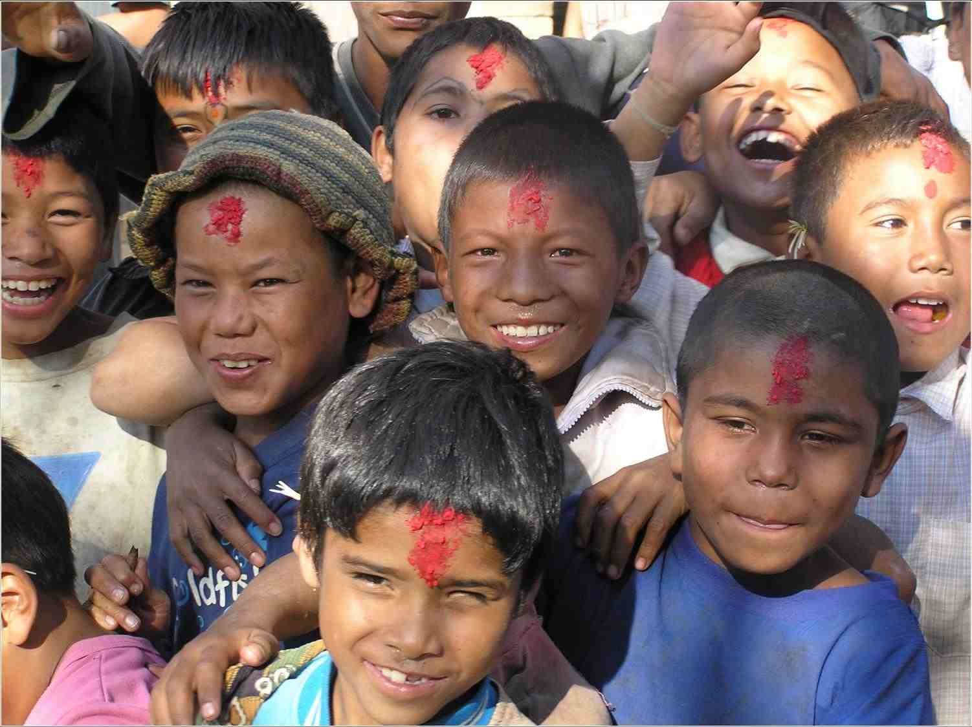
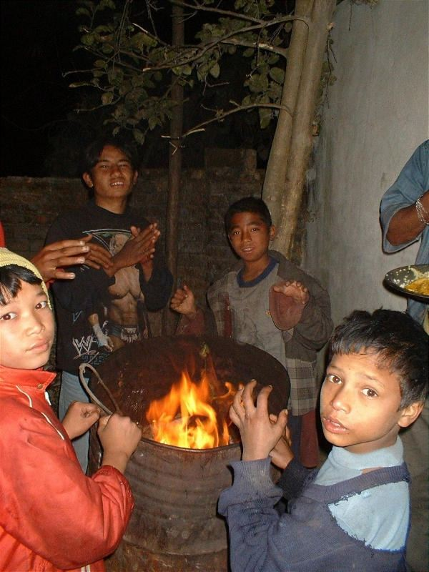
*** We heard earlier from Jean Christoph Ryckmans about Chandrodaya, and the work it is doing to help Kathmandu’s homeless children. Here are two pictures of some of the boys.*** *** This Friday our speaker will be Ravindra Shakya. He has been the Country Director for SPW (Student Partnership Worldwide) in Nepal for nearly six years. SPW seeks to strengthen rural government schools, particularly the non-formal and extra-curricular side of school life. He served earlier with the British Council, Oxfam, CRS, and the UMN.

Hope to see you on Friday morning. YIR…David

